Cisco ACI Profiler

OVA Deployment Guide

Release 1.0

Contents

Introduction 1

Deploy OVA 1

Configure Virtual Machine 5

IP Address Configuration 5

Static IP address Change 5

DHCP 6

Access Application 6

# 

# Introduction

This document describes in setting up of a VM and profiler application from a OVA.

Please download CiscoNetworkProfiler.ova .ova and follow below steps to deploy in a VMWare ESXI/vCenter.

# Deploy OVA

Step 1: Open vSphere client. Go to File->Deploy OVF Template

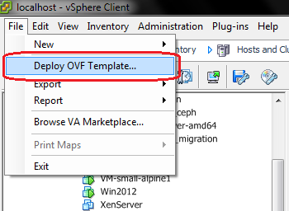

Step 2: Select the OVA file you want to deploy from the disk and click next

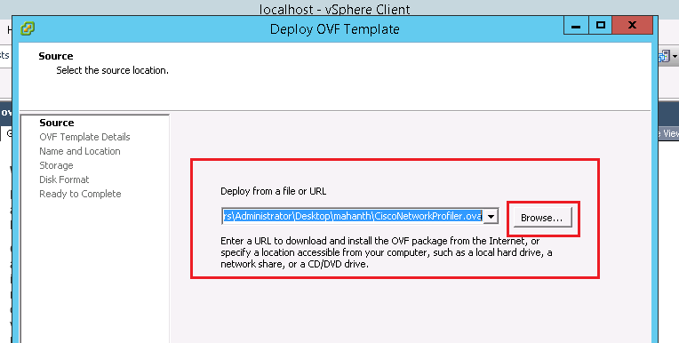

Click next after reading summary in OVF templates details

Step 3: Give a name for the VM and click next

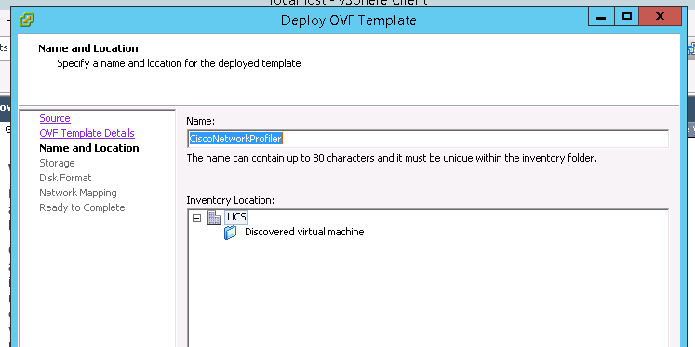

Step 4: Select Datastore where you want to deploy the VM

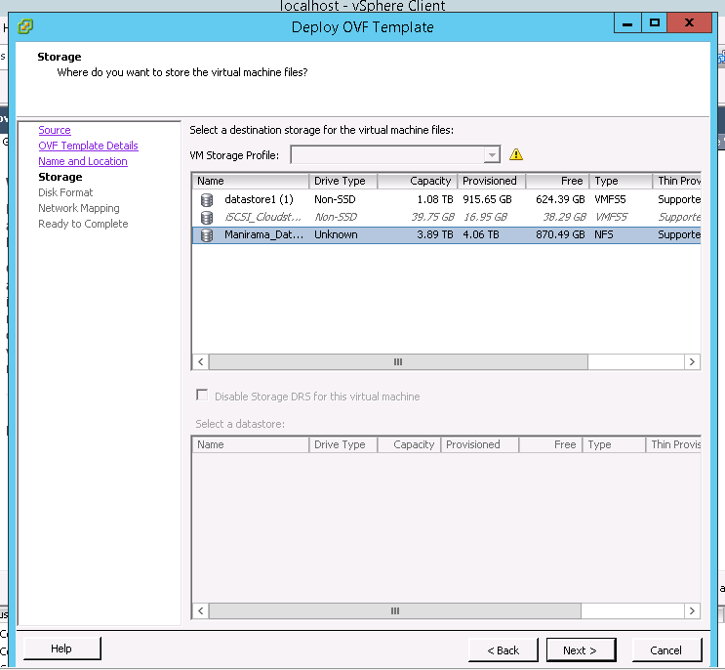

Step 5: Select power on VM after deploy and select finish

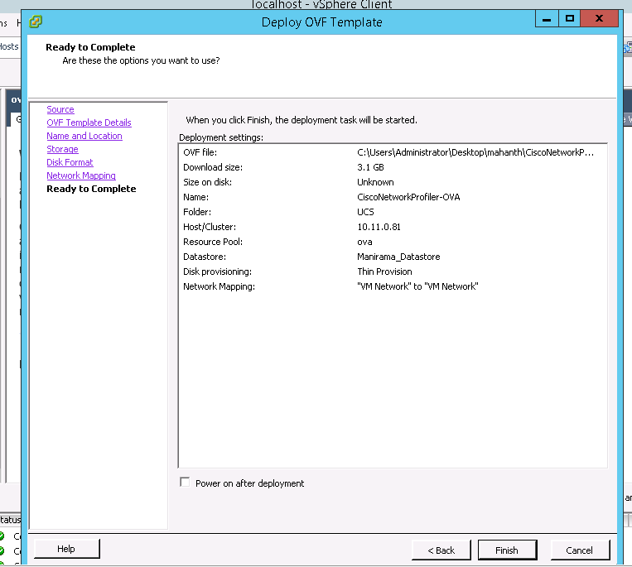

Wait for the deployment task to complete.

.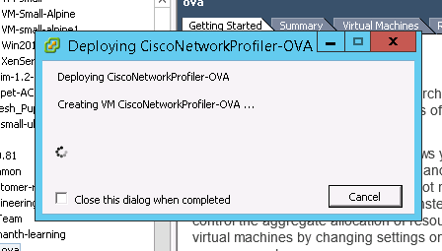

After Completion

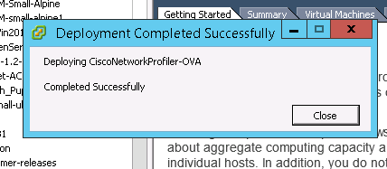

# Configure Virtual Machine

## IP Address Configuration

Step 1: Power ON VM after deploying and select console tab and login to console.

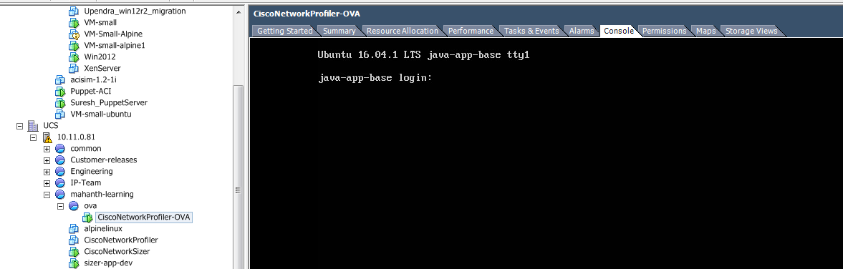

Username: appadmin

Password: password

Edit the /etc/network/interfaces file

Sudo vi/etc/network/interfaces

Enter password if prompted

### Static IP address Change

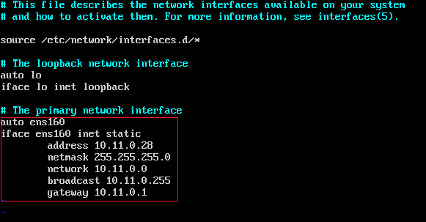

Update the address, netmask, network, broadcast and gateway according to your network settings.

Save and restart VM

### DHCP

If you are using DHCP in your network, then add below lines to ens160 interface as shown below.

auto ens160

iface ens160 inet dhcp

Save and restart VM

# Access Application

Application is configured to run on port 8080. Access application using URL http://<<IP address>>:8080/

Use below credentials to login to application.

User name: admin

Password: admin

Refer application user guide for more information on application features.